BANK LOAN REPORT|SUMMARY

Total Loan Applications

Select count(id) as 'Total Applications' from bank_loan
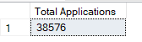

MTD Total Applications

Select count(id) as 'MTD Total Applications' from bank_loan
where MONTH(issue_date)=12 and YEAR(issue_date)=2021;
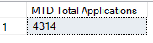

PMTD Total Applications

Select count(id) as 'PMTD Total Applications' from bank_loan
where MONTH(issue_date)=11 and YEAR(issue_date)=2021
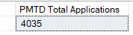

Total Funded Amount

SELECT SUM(loan_amount) AS Total_Funded_Amount FROM bank_loan
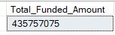

MTD Total Funded Amount

SELECT SUM(loan_amount) AS MTD_Total_Funded_Amount FROM bank_loan
WHERE MONTH(issue_date) = 12
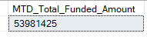

PMTD Total Funded Amount

SELECT SUM(loan_amount) AS PMTD_Total_Funded_Amount FROM bank_loan
WHERE MONTH(issue_date) = 11
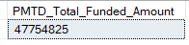

Total Amount Received

SELECT SUM(total_payment) AS Total_Amount_Collected FROM bank_loan
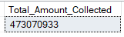

MTD Total Amount Received

SELECT SUM(total_payment) AS MTD_Total_Amount_Collected FROM bank_loan
WHERE MONTH(issue_date) = 12
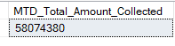
PMTD Total Amount Received

SELECT SUM(total_payment) AS PMTD_Total_Amount_Collected FROM bank_loan
WHERE MONTH(issue_date) = 11
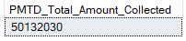

Average Interest Rate

SELECT AVG(int_rate)*100 AS Avg_Int_Rate FROM bank_loan
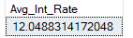

MTD Average Interest

SELECT AVG(int_rate)*100 AS MTD_Avg_Int_Rate FROM bank_loan
WHERE MONTH(issue_date) = 12
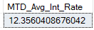

PMTD Average Interest

SELECT AVG(int_rate)*100 AS PMTD_Avg_Int_Rate FROM bank_loan
WHERE MONTH(issue_date) = 11
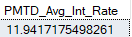

Avg DTI

SELECT AVG(dti)*100 AS Avg_DTI FROM bank_loan
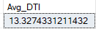
MTD Avg DTI

SELECT AVG(dti)*100 AS MTD_Avg_DTI FROM bank_loan
WHERE MONTH(issue_date) = 12
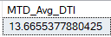

PMTD Avg DTI

SELECT AVG(dti)*100 AS PMTD_Avg_DTI FROM bank_loan
WHERE MONTH(issue_date) = 11
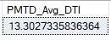

GOOD LOAN ISSUED

Good Loan Percentage

SELECT
(COUNT(CASE WHEN loan_status = 'Fully Paid' OR loan_status = 'Current' THEN id END) * 100.0) /
COUNT(id) AS Good_Loan_Percentage
FROM bank_loan

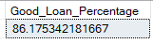

Good Loan Applications

SELECT COUNT(id) AS Good_Loan_Applications FROM bank_loan
WHERE loan_status = 'Fully Paid' OR loan_status = 'Current'
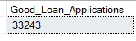

Good Loan Funded Amount

SELECT SUM(loan_amount) AS Good_Loan_Funded_amount FROM bank_loan
WHERE loan_status = 'Fully Paid' OR loan_status = 'Current'
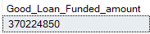

Good Loan Amount Received

SELECT SUM(total_payment) AS Good_Loan_amount_received FROM bank_loan
WHERE loan_status = 'Fully Paid' OR loan_status = 'Current'
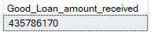

BAD LOAN ISSUED

Bad Loan Percentage

SELECT
(COUNT(CASE WHEN loan_status = 'Charged Off' THEN id END) * 100.0) /
COUNT(id) AS Bad_Loan_Percentage
FROM bank_loan
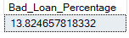

Bad Loan Applications

SELECT COUNT(id) AS Bad_Loan_Applications FROM bank_loan
WHERE loan_status = 'Charged Off'
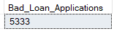

Bad Loan Funded Amount

SELECT SUM(loan_amount) AS Bad_Loan_Funded_amount FROM bank_loan
WHERE loan_status = 'Charged Off'
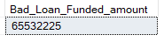

Bad Loan Amount Received

SELECT SUM(total_payment) AS Bad_Loan_amount_received FROM bank_loan
WHERE loan_status = 'Charged Off'
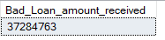

LOAN STATUS

SELECT
loan_status,
COUNT(id) AS LoanCount,
SUM(total_payment) AS Total_Amount_Received,
SUM(loan_amount) AS Total_Funded_Amount,
AVG(int_rate * 100) AS Interest_Rate,
AVG(dti * 100) AS DTI
FROM
bank_loan
GROUP BY
loan_status
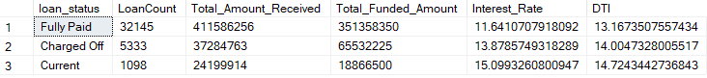

SELECT
loan_status,
SUM(total_payment) AS MTD_Total_Amount_Received,
SUM(loan_amount) AS MTD_Total_Funded_Amount
FROM bank_loan
WHERE MONTH(issue_date) = 12
GROUP BY loan_status

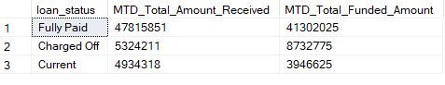

- BANK LOAN REPORT | OVERVIEW

SELECT
MONTH(issue_date) AS Month_Munber,
DATENAME(MONTH, issue_date) AS Month_name,
COUNT(id) AS Total_Loan_Applications,
SUM(loan_amount) AS Total_Funded_Amount,
SUM(total_payment) AS Total_Amount_Received
FROM bank_loan
GROUP BY MONTH(issue_date), DATENAME(MONTH, issue_date)
ORDER BY MONTH(issue_date)
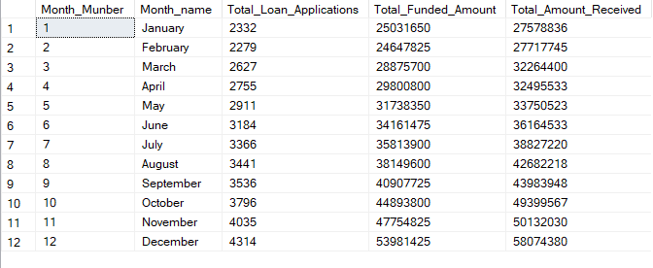

SELECT
address_state AS State,
COUNT(id) AS Total_Loan_Applications,
SUM(loan_amount) AS Total_Funded_Amount,
SUM(total_payment) AS Total_Amount_Received
FROM bank_loan
GROUP BY address_state
ORDER BY address_state
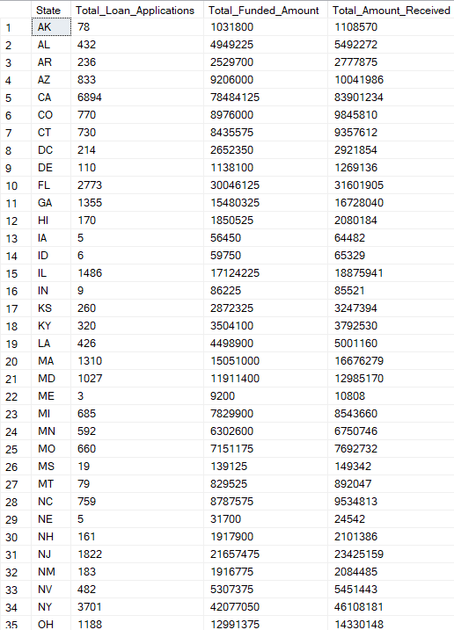
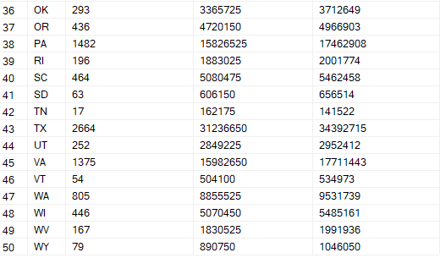

TERM

SELECT
term AS Term,
COUNT(id) AS Total_Loan_Applications,
SUM(loan_amount) AS Total_Funded_Amount,
SUM(total_payment) AS Total_Amount_Received
FROM bank_loan
GROUP BY term
ORDER BY term
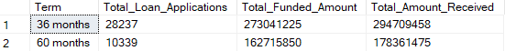

EMPLOYEE LENGTH

SELECT
emp_length AS Employee_Length,
COUNT(id) AS Total_Loan_Applications,
SUM(loan_amount) AS Total_Funded_Amount,
SUM(total_payment) AS Total_Amount_Received
FROM bank_loan
GROUP BY emp_length
ORDER BY emp_length

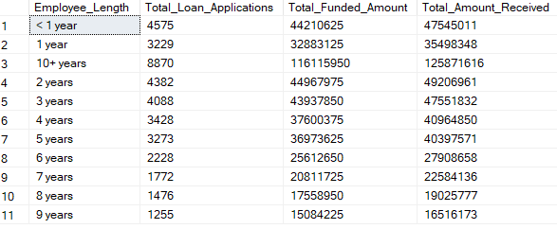

PURPOSE

SELECT
purpose AS PURPOSE,
COUNT(id) AS Total_Loan_Applications,
SUM(loan_amount) AS Total_Funded_Amount,
SUM(total_payment) AS Total_Amount_Received
FROM bank_loan
GROUP BY purpose
ORDER BY purpose
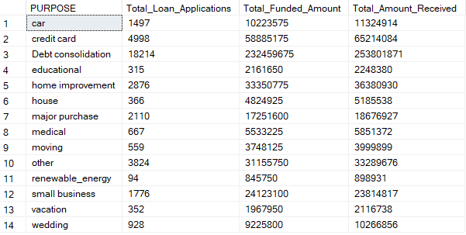

HOME OWNERSHIP

SELECT
home_ownership AS Home_Ownership,
COUNT(id) AS Total_Loan_Applications,
SUM(loan_amount) AS Total_Funded_Amount,
SUM(total_payment) AS Total_Amount_Received
FROM bank_loan
GROUP BY home_ownership
ORDER BY home_ownership
